

**Marketing Research Project**

**MKTG8005 – Applied Marketing Research**

**Assessment 3 – Data Analysis and Reporting**

**Submitted by**

Raj Katare

Student Id: 46843302

Master of Business Analytics

Macquarie University

1. **Performing descriptive analysis**
2. **Perceived well-being (WB)**

**WB1:** This event met my overall well-being needs.

**WB2:** This event played a very important role in my social well-being.

**WB3:** This event played an important role in my travel well-being.

**WB4:** This event played an important role in enhancing my quality of life.

In the case of WB4, we can observe that there is one missing value. Furthermore, we can find out that there are outliers present as the maximum value for WB4 is 11 and the survey ranges from Likert scale ranges from 1 to 7. The output for the outliers for WB4 is as follows:

The screenshot of the data view after replacing the outlier with the missing value is as follows:

As observed from the previous 2 tables above, the value **11** on the 10th row is now replaced with NULL. Hence, we will replace the missing/NULL values with the mean of the values of WB4 as the values are scalable.

Replacing the missing values includes creating a new variable (WB4_1 in this case) which contains the mean in the place of missing values. The output is as follows:

The number of values replaced is 2 and the mean value is 3.2. Hence, we round up these values to 3 as the values of the scales are a whole number.

To understand the normality of perceived well-being with the perspective of normal distribution. It can be demonstrated as:

Skewness needs to be between -1 and +1 and Kurtosis needs to be between -3 to +3 for the data to demonstrate a normal distribution.

The results demonstrate Kurtosis and Skewness tests show that all 4 items are normally distributed, as all the indices fit between both skewness as well as kurtosis indicated intervals.

For the mean statistics:

There was an average of 3.91 responses to this item (WB1).

There was an average of 3.55 responses to this item (WB2).

There was an average of 3.75 responses to this item (WB3).

There was an average of 3.19 responses to this item (WB4_1).

This means most respondents had a **neutral** response based on perceived well-being.

**WB1:**

**WB2:**

**WB3:**

**WB4:**

1. **Special Event Prestige (PRE)**

**PRE1:** This event is a very prestigious event.

**PRE2:** This event is one of the best special events for culture.

**PRE3:** This event is a first-class, high-quality tourism special event.

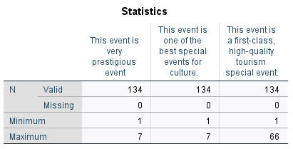

In the case of PRE3 from the above table, we can observe that there is no missing value. However, we can find out that there are outliers present as the maximum value for PRE3 is 66 and the survey ranges from Likert scale ranges from 1 to 7. The output for the outliers for WB4 is as follows:

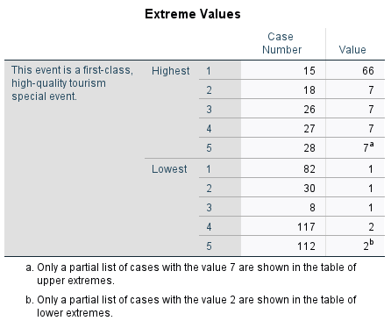

The outlier is observed at row 15 with the value 66 and we will replace this value with the NULL value. Hence, we will further replace the NULL value with the mean of PRE3 as the values are scalable.

As we can see that the mean value is 5.46. Hence, as only one value is an outlier, we replace row 15 with the closest whole number of 5.46 which is 6.

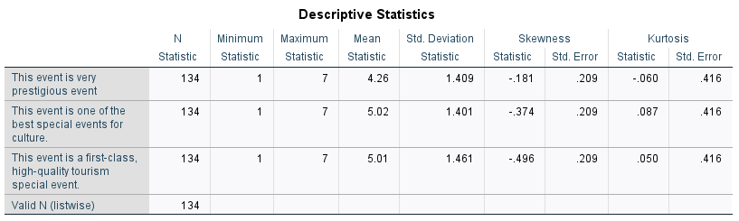

Skewness needs to be between -1 and +1 and Kurtosis needs to be between -3 to +3 for the data to demonstrate a normal distribution.

The results demonstrate Kurtosis and Skewness tests show that all 3 items are normally distributed, as all the indices fit between both skewness as well as kurtosis indicated intervals.

For the mean statistics:

There was an average of 4.26 responses to this item (PRE1).

There was an average of 5.02 responses to this item (PRE2).

There was an average of 5.01 responses to this item (PRE3).

This means the average response was **somewhat agreeable** based on Special Event Prestige.

**PRE1:**

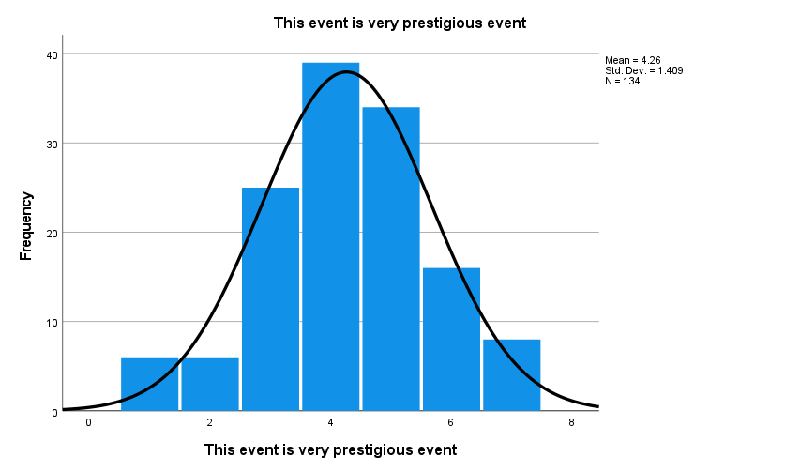

**PRE2:**

**PRE3:**

1. **Involvement in special events (INV)**

**INV1:** I am very interested in anything related to special event tourism.

**INV2:** Which tourism special events I attend matters a lot.

**INV3:** I value tourism special events as an important part of my life.

**INV4:** Tourism special events means a lot to me.

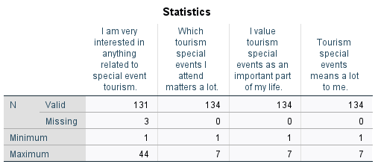

In the case of INV1, we can observe that there are 3 missing values. Furthermore, we can find out that there are outliers present as the maximum value for INV1 is 44 and the survey ranges from Likert scale ranges from 1 to 7. The output for the outliers for INV1 is as follows:

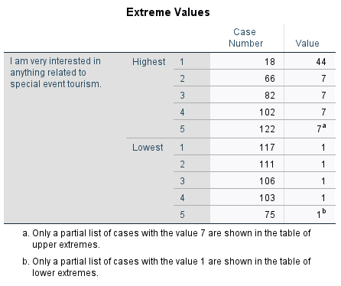

As observed from the previous 2 tables above, the value **44** on the 18th row is now replaced with NULL. Hence, we will replace the missing/NULL values with the mean of the values of INV1 as the values are scalable.

Replacing the missing values includes creating a new variable (INV1_1 in this case) which contains the mean in the place of missing values. The output is as follows:

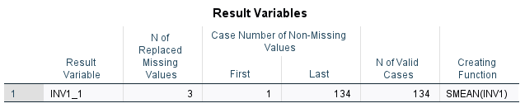

The number of values replaced is 4 and the mean value is 3.7. Hence, we round up these values to 4 as the values of the scales are a whole number.

To understand the normality of Involvement in special events with the perspective of normal distribution. It can be demonstrated as:

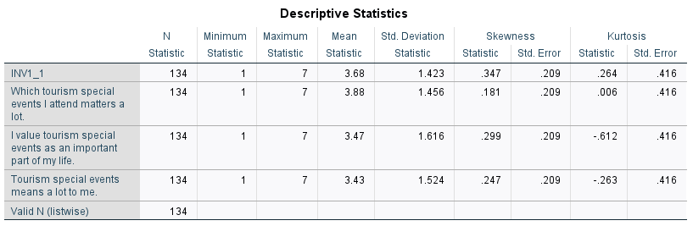

Skewness needs to be between -1 and +1 and Kurtosis needs to be between -3 to +3 for the data to demonstrate a normal distribution.

The results demonstrate Kurtosis and Skewness tests show that all 4 items are normally distributed, as all the indices fit between both skewness as well as kurtosis indicated intervals.

For the mean statistics:

There was an average of 3.68 responses to this item (INV1_1).

There was an average of 3.88 responses to this item (INV2).

There was an average of 3.47 responses to this item (INV3).

There was an average of 3.43 responses to this item (INV4).

This means the average response was **neutral** based on Involvement in special events.

**INV1_1:**

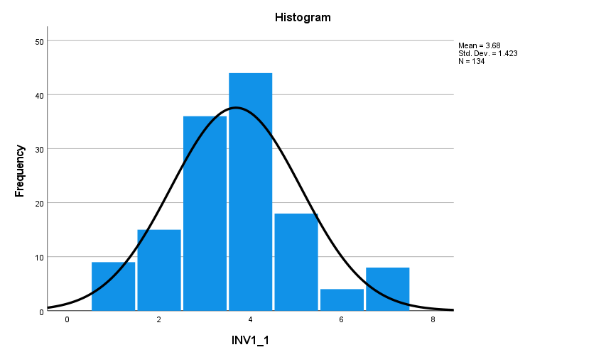

**INV2:**

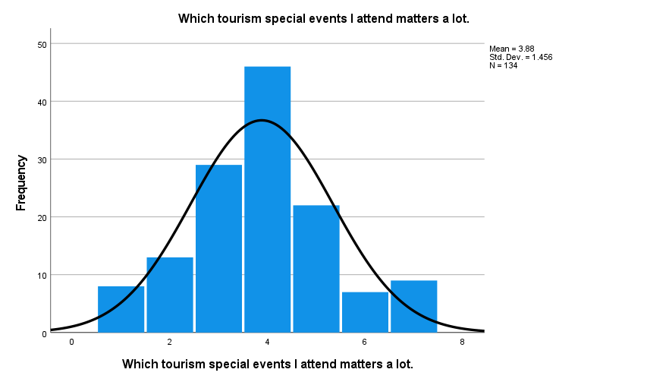

**INV3:**

**INV4:**

1. **Overall Experience (EX)**

**EX1:** I will have a lot of memorable experiences about this event.

**EX2:** Thinking of this event will bring back good memories.

**EX3:** I will have fond memories of this event.

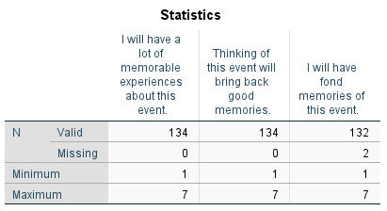

In the case of EX3 from the above table, we can observe that there are 2 missing values and no outliers.

Hence, we replace the missing values includes creating a new variable (EX3_1 in this case) which contains the mean in the place of missing values. The output is as follows:

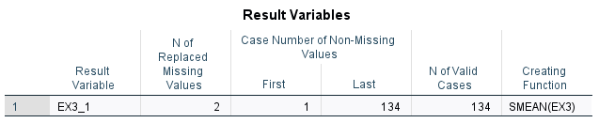

The number of values replaced is 2 and the mean value is 4.4. Hence, we round up these values to 4 as the values of the scales are a whole number.

To understand the normality of Overall experience variable with the perspective of normal distribution. It can be demonstrated as:

Skewness needs to be between -1 and +1 and Kurtosis needs to be between -3 to +3 for the data to demonstrate a normal distribution.

The results demonstrate Kurtosis and Skewness tests show that all 4 items are normally distributed, as all the indices fit between both skewness as well as kurtosis indicated intervals.

For the mean statistics:

There was an average of 3.92 responses to this item (EX1).

There was an average of 4.20 responses to this item (EX2).

There was an average of 4.38 responses to this item (EX3_1).

This means the average response was **neutral** based on Overall Experience.

**EX1:**

**EX2:**

**EX3_1:**

1. **Word of Mouth (WOM)**

**WOM1:** I like recommending this event to other people.

**WOM2:** I love to talk about the good points of this event to people I know.

**WOM3:** I have managed to convince other people to attend this event.

In the case of WOM2 from the above table, we can observe that there are 2 missing values and no outliers.

Hence, we replace the missing values includes creating a new variable (WOM2_1 in this case) which contains the mean in the place of missing values. The output is as follows:

The number of values replaced is 2 and the mean value is 4.5. Hence, we round up these values to 5 as the values of the scales are a whole number.

To understand the normality of Word-of-Mouth variable with the perspective of normal distribution. It can be demonstrated as:

Skewness needs to be between -1 and +1 and Kurtosis needs to be between -3 to +3 for the data to demonstrate a normal distribution.

The results demonstrate Kurtosis and Skewness tests show that all 4 items are normally distributed, as all the indices fit between both skewness as well as kurtosis indicated intervals.

For the mean statistics:

There was an average of 4.46 responses to this item (WOM1).

There was an average of 4.47 responses to this item (WOM2_1).

There was an average of 4.36 responses to this item (WOM3).

This means the average response was **somewhat agreeable** based on word of mouth.

**WOM1:**

**WOM2_1:**

**WOM3:**

1. **Social Media Engagement (SM)**

**SM1:** I used social media to interact with friends about this event.

**SM2:** social media provided a way for me to stay connected to people across distances.

**SM3:** I used social media to tell others about this event.

**SM4:** I posted/shared photos/videos for friends/family and acquaintances, on social media (e.g., Facebook).

**SM5:** I wanted to inspire other people about this event with my social media posts.

**SM6:** I liked to share my impressions about this event through social media.

**SM7:** It made me feel accepted when people commented on my social media posts.

As observed from the table above, there is one missing value in the SM4 variable, 2 missing values in SM6, and 1 missing value in SM7 variable. Furthermore, there are outliers present in SM4 as the maximum value is 52.

The output for the outliers for SM4 is as follows:

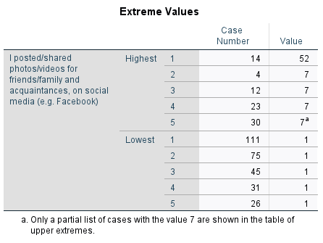

As observed from the table above, the value **52** is present as an outlier on the 14th row. Hence, this value is now replaced with NULL. Hence, we will replace the missing/NULL values with the mean of the values of INV1 as the values are scalable.

Replacing the missing values includes creating new variables (SM4_1, SM6_1 and SM7_1 in this case) which contains the mean in the place of missing values. The output is as follows:

For SM4_1 variable, the number of values replaced is 2 and the mean value is 4.6. Hence, we round up these values to 5 as the values of the scales are a whole number.

For SM6_1 variable, the number of values replaced is 2 and the mean value is 4.3. Hence, we round up these values to 4 as the values of the scales are a whole number.

For SM7_1 variable, the number of values replaced is 1 and the mean value is 4.2. Hence, we round up these values to 4 as the values of the scales are a whole number.

To understand the normality of Social Media Engagement variable with the perspective of normal distribution. It can be demonstrated as:

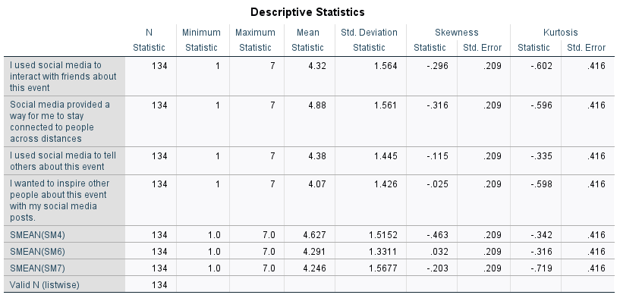

Skewness needs to be between -1 and +1 and Kurtosis needs to be between -3 to +3 for the data to demonstrate a normal distribution.

The results demonstrate Kurtosis and Skewness tests show that all 4 items are normally distributed, as all the indices fit between both skewness as well as kurtosis indicated intervals.

For the mean statistics:

There was an average of 4.32 responses to this item (SM1).

There was an average of 4.88 responses to this item (SM2).

There was an average of 4.38 responses to this item (SM3).

There was an average of 4.63 responses to this item (SM4_1).

There was an average of 4.07 responses to this item (SM5).

There was an average of 4.29 responses to this item (SM6_1).

There was an average of 4.25 responses to this item (SM7_1).

This means the average response was **neutral** based on Social Media Engagement variable.

**SM1:**

**SM2:**

**SM3:**

**SM4_1:**

**SM5:**

**SM6_1:**

**SM7_1:**

